727721EUIT167

SWATHI R

**CODING CONTEST-1**

Q1.

**package** com.CA1.ca1;

**import** org.openqa.selenium.By;

**import** org.openqa.selenium.Keys;

**import** org.openqa.selenium.WebDriver;

**import** org.openqa.selenium.WebElement;

**import** org.openqa.selenium.firefox.FirefoxDriver;

**import** org.openqa.selenium.interactions.Actions;

**import** io.github.bonigarcia.wdm.WebDriverManager;

**public** **class** CC1 {

**public** **static** **void** main( String[] args ) **throws** InterruptedException

{

WebDriverManager.*firefoxdriver*().setup();

WebDriver driver = **new** FirefoxDriver();

driver.manage().window().maximize();

driver.navigate().to("https://www.saucedemo.com/");

driver.manage().window().maximize();

driver.findElement(By.*xpath*("//*[@id=\"user-name\"]")).sendKeys("standard_user");

driver.findElement(By.*xpath*("//*[@id=\"password\"]")).sendKeys("secret_sauce");

driver.findElement(By.*xpath*("//*[@id=\"login-button\"]")).click();

driver.findElement(By.*xpath*("//*[@id=\"add-to-cart-sauce-labs-backpack\"]")).click();

String cartNum = driver.findElement(By.*xpath*("/html/body/div/div/div/div[1]/div[1]/div[3]/a/span")).getText();

**if** (cartNum.equals("1")) {

System.***out***.println("Added to cart successfully");

}

driver.findElement(By.*xpath*("/html/body/div/div/div/div[1]/div[1]/div[3]/a")).click();

String prodStr = "Sauce Labs Backpack";

**if**(driver.findElement(By.*xpath*("/html/body/div/div/div/div[2]/div/div[1]/div[3]/div[2]/a/div")).getText().equals(prodStr));

{

System.***out***.println("User can view the contents of the cart");

}

driver.findElement(By.*xpath*("//*[@id=\"checkout\"]")).click();

**if**(driver.findElement(By.*xpath*("/html/body/div/div/div/div[1]/div[2]/span")).getText().equals("Checkout: Your Information")) {

System.***out***.println("Your information form is displayed");

}

driver.findElement(By.*xpath*("//*[@id=\"first-name\"]")).sendKeys("Swathi");

driver.findElement(By.*xpath*("//*[@id=\"last-name\"]")).sendKeys("R");

driver.findElement(By.*xpath*("//*[@id=\"postal-code\"]")).sendKeys("641042");

driver.findElement(By.*xpath*("//*[@id=\"continue\"]")).click();

**if**(driver.findElement(By.*xpath*("/html/body/div/div/div/div[1]/div[2]/span")).getText().equals("Checkout: Overview")) {

System.***out***.println("Product overview page is displayed");

}

System.***out***.println("Name of the product: " + driver.findElement(By.*xpath*("/html/body/div/div/div/div[2]/div/div[1]/div[3]/div[2]/a/div")).getText());

System.***out***.println("Price of the product: " + driver.findElement(By.*xpath*("/html/body/div/div/div/div[2]/div/div[1]/div[3]/div[2]/div[2]/div")).getText());

**if**(driver.getTitle().equals("Swag Labs")) {

System.***out***.println("Title is matched");

}

**if**(driver.getCurrentUrl().equals("https://www.saucedemo.com/checkout-step-two.html")) {

System.***out***.println("URL is matched");

}

}

}

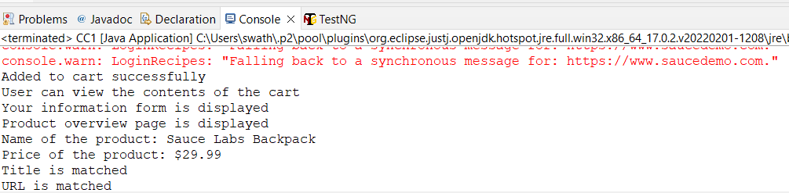

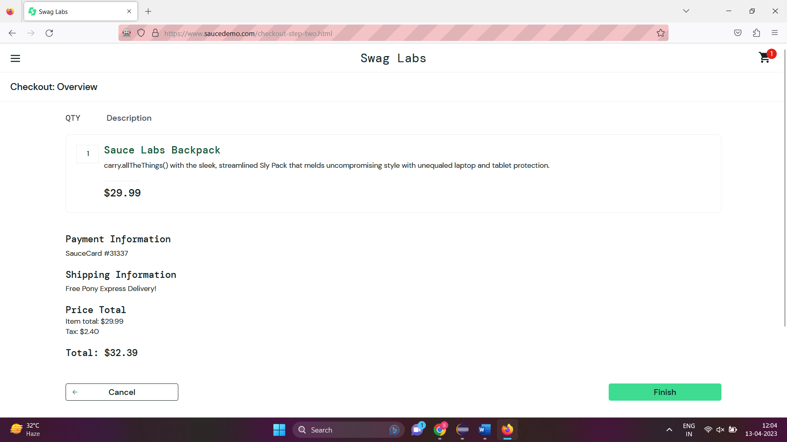

Q2.

**package** com.CA1.ca1;

**import** org.openqa.selenium.By;

**import** org.openqa.selenium.WebDriver;

**import** org.openqa.selenium.WebElement;

**import** org.openqa.selenium.chrome.ChromeDriver;

**import** org.openqa.selenium.chrome.ChromeOptions;

**import** io.github.bonigarcia.wdm.WebDriverManager;

**public** **class** CC1_Q2 {

**public** **static** **void** main(String[] args) **throws** InterruptedException {

// **TODO** Auto-generated method stub

ChromeOptions co=**new** ChromeOptions();

co.addArguments ("--remote-allow-origins=*");

WebDriverManager.*chromedriver*().setup ();

WebDriver driver=**new** ChromeDriver(co);

driver.get ("https://www.saucedemo.com/");

driver.manage().window().maximize() ;

WebElement txtBoxl=driver.findElement(By.*xpath*("//*[@id=\"user-name\"]"));

txtBoxl.sendKeys("standard_user");

WebElement txtBox2=driver.findElement(By.*xpath*("//*[@id=\"password\"]"));

txtBox2.sendKeys("secret_sauce");

driver.findElement(By.*xpath*("//*[@id=\"login-button\"]")).click();

String txt1=driver.findElement(By.*xpath*("//*[@id=\"item_4_title_link\"]/div")).getText();

System.***out***.println(txt1);

driver.findElement(By.*xpath*("//*[@id=\"header_container\"]/div[2]/div/span/select")).click();

driver.findElement(By.*xpath*("//*[@id=\"header_container\"]/div[2]/div/span/select/option[2]")).click();

String txt2=driver.findElement(By.*xpath*("//*[@id=\"item_3_title_link\"]/div")).getText();

System.***out***.println(txt2);

driver.findElement(By.*xpath*("//*[@id=\"header_container\"]/div[2]/div/span/select")).click();

driver.findElement(By.*xpath*("//*[@id=\"header_container\"]/div[2]/div/span/select/option[3]")).click();

String txt3=driver.findElement(By.*xpath*("//*[@id=\"item_2_title_link\"]/div")).getText();

System.***out***.println(txt3);

driver.findElement(By.*xpath*("//*[@id=\"header_container\"]/div[2]/div/span/select")).click();

driver.findElement(By.*xpath*("//*[@id=\"header_container\"]/div[2]/div/span/select/option[4]")).click();

String txt4=driver.findElement(By.*xpath*("//*[@id=\"item_5_title_link\"]/div")).getText();

System.***out***.println(txt4);

Thread.*sleep*(5000);

}

}

